ALBERT MWANGWA ABEDI MODEST

SECOND YEAR, UDSM SECOND YEAR, RUCU

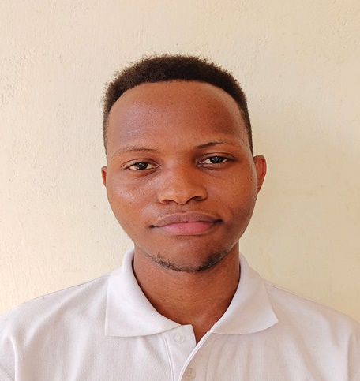 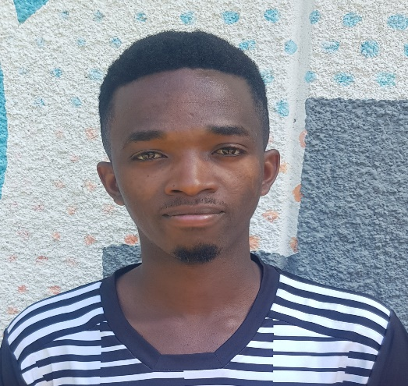

PHILIP HUGO GLADNESS GODFREY

THIRD YEAR, UDSM SECOND YEAR, UDSM

